Corporate Finance, (Berk/DeMarzo)
Chapter 22 Real Options

22.1 Real Versus Financial Options

1) Which of the following statements is FALSE?
A) In particular, because real options allow a decision maker to choose the most attractive alternative after new information has been learned, the presence of real options adds value to an investment opportunity.
B) To make an investment decision correctly, the value of embedded real options must be included in the decision-making process.
C) A key distinction between a real option and a financial option is that real options, and the underlying assets on which they are based, are often traded in competitive markets.
D) We can compute the value of the real option by comparing the expected profit without the real option to the value with the option.
Answer: C
Explanation: C) A key distinction between a real option and a financial option is that real options, and the underlying assets on which they are based, are not traded in competitive markets.
Diff: 1
Section: 22.1 Real Versus Financial Options
Skill: Conceptual

2) Which of the following is NOT a real option?
A) A stock option
B) An abandonment option
C) An investment timing option
D) An expansion option
Answer: A
Diff: 1
Section: 22.1 Real Versus Financial Options
Skill: Conceptual

22.2 Decision Tree Analysis

1) Which of the following statements is FALSE?
A) Decision nodes are nodes in which uncertainty is involved that is out of the control of the decision maker.
B) Most investment projects allow for the possibility of reevaluating the decision to invest at a later point in time.
C) A decision tree is a graphical representation of future decisions and uncertainty resolution.
D) With binomial trees the uncertainty is not under the control of the decision maker.
Answer: A
Diff: 1
Section: 22.2 Decision Tree Analysis
Skill: Conceptual
2) The two different types of node on a decision tree are:
A) information and decision nodes.
B) information and uncertainty nodes.
C) uncertainty and decision nodes.
D) go to meet and stay home nodes.
Answer: A
Diff: 1
Section: 22.1 Real Versus Financial Options
Skill: Definition

22.3 The Option to Delay an Investment Opportunity

1) Which of the following statements is FALSE?
A) One way to see why you sometimes choose not to invest in a positive-NPV project is to think about the decision of when to invest as a choice between two mutually exclusive projects: (1) invest today or (2) wait.
B) You invest today only when the NPV of investing today exceeds the value of the option of waiting, which from option pricing theory we know to be always positive.
C) When you do not have the option to wait, it is optimal to invest in any positive-NPV project.
D) When you have the option of deciding when to invest, it is usually optimal to invest only when the NPV is positive but close to zero.
Answer: D
Explanation: D) When you have the option of deciding when to invest, it is usually optimal to invest only when the NPV is substantially positive.
Diff: 2
Section: 22.3 The Option to Delay an Investment Opportunity
Skill: Conceptual

2) Which of the following statements is FALSE?
A) If there is a lot of uncertainty, the benefit of waiting is diminished.
B) In the real option context, the dividends correspond to any value from the investment that we give up by waiting.
C) By delaying an investment, we can base our decision on additional information.
D) Given the option to wait, an investment that currently has a negative NPV can have a positive value.
Answer: A
Explanation: A) If there is a lot of uncertainty, the benefit of waiting is increased.
Diff: 2
Section: 22.3 The Option to Delay an Investment Opportunity
Skill: Conceptual
3) Which of the following statements is FALSE?
A) Aside from the current NPV of the investment, other factors affect the value of an investment and the decision to wait.
B) The option to wait is most valuable when there is a great deal of uncertainty regarding what the value of the investment will be in the future.
C) The smaller the cost of waiting, the less attractive the option to delay becomes.
D) It is always better to wait to invest unless there is a cost to doing so.
Answer: C
Explanation: C) The smaller the cost of waiting, the more attractive the option to delay becomes.
Diff: 2
Section: 22.3 The Option to Delay an Investment Opportunity
Skill: Conceptual

Use the information for the question(s) below.

Kinston Industries has come up with a new mountain bike prototype and is ready to go ahead with pilot production and test marketing. The pilot production and test marketing phase will last for one year and cost $500,000. Your management team believes that there is a 50% chance that the test marketing will be successful and that there will be sufficient demand for the new mountain bike. If the test-marketing phase is successful, then Kinston Industries will invest $3 million in year one to build a plant that will generate expected annual after tax cash flows of $400,000 in perpetuity beginning in year two. If the test marketing is not successful, Kinston can still go ahead and build the new plant, but the expected annual after tax cash flows would be only $200,000 in perpetuity beginning in year two. Kinston has the option to stop the project at any time and sell the prototype mountain bike to an overseas competitor for $300,000. Kinston's cost of capital is 10%.

4) Assuming that Kinston has the ability to sell the prototype in year one for $300,000, the NPV of the Kinston Industries Mountain Bike Project is closest to:
A) $90,000
B) $590,000
C) $455,000
D) -$45,000
Answer: A
Explanation: A) Value if test is successful
Build plant: NPV = -$3,000,000 + 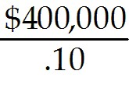 = $1,000,000
Value if test unsuccessful
Build plant NPV = -$3,000,000 + 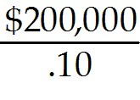 = -$1,000,000
Don't Build (Sell Prototype) NPV = $300,000
Since $300,000 > -$500,000 you should sell prototype if test is unsuccessful

NPV = 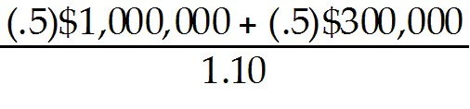 - $500,000 = $90,909
Diff: 3
Section: 22.3 The Option to Delay an Investment Opportunity
Skill: Analytical
5) Assuming that Kinston does not have the ability to sell the prototype in year one for $300,000, the NPV of the Kinston Industries Mountain Bike Project is closest to:
A) -$45,000
B) $455,000
C) $590,000
D) $90,000
Answer: A
Explanation: A) Value if test is successful
Build plant: NPV = -$3,000,000 + = $1,000,000
Value if test unsuccessful
Build plant NPV = -$3,000,000 + = -$1,000,000
Don't Build (abandon) NPV = $0
Since $0 > -$500,000 you should abandon

NPV = 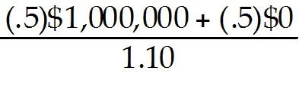 - $500,000 = -$45,455
Diff: 3
Section: 22.3 The Option to Delay an Investment Opportunity
Skill: Analytical

6) Assume that Kinston has the ability to ignore the pilot production and test marketing and to go ahead and build their manufacturing plant immediately. Assuming that the probability of high or low demand is still 50%, the NPV of the Kinston Industries Mountain Bike Project is closest to:
A) $0
B) $90,000
C) -$45,000
D) $1,000,000
Answer: A
Explanation: A) NPV = 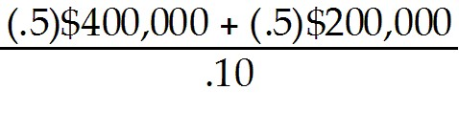 - $3,000,000 = $0
Diff: 2
Section: 22.3 The Option to Delay an Investment Opportunity
Skill: Analytical
7) Assume that Kinston has the ability to ignore the pilot production and test marketing and to go ahead and build their manufacturing plant immediately and that the probability of high or low demand would still be 50%. What is the value of the the option to do pilot production and test marketing?
Answer: The NPV of going ahead and building today (No pilot production and test marketing option):
NPV = - $3,000,000 = $0
NPV with pilot production and test marketing option:

Value if test is successful
Build plant: NPV = -$3,000,000 + = $1,000,000

Value if test unsuccessful
Build plant NPV = -$3,000,000 + = -$1,000,000
Don't Build (Sell Prototype) NPV = $300,000
Since $300,000 > -$500,000 you should sell prototype

NPV = - $500,000 = $90,909
So, value of option = $90,909 - $0 = $90,909
Diff: 3
Section: 22.3 The Option to Delay an Investment Opportunity
Skill: Analytical

8) Assuming that Kinston has the ability to sell the prototype in year one for $300,000, draw a decision tree detailing the Kinston Industries Mountain Bike Project.
Answer:
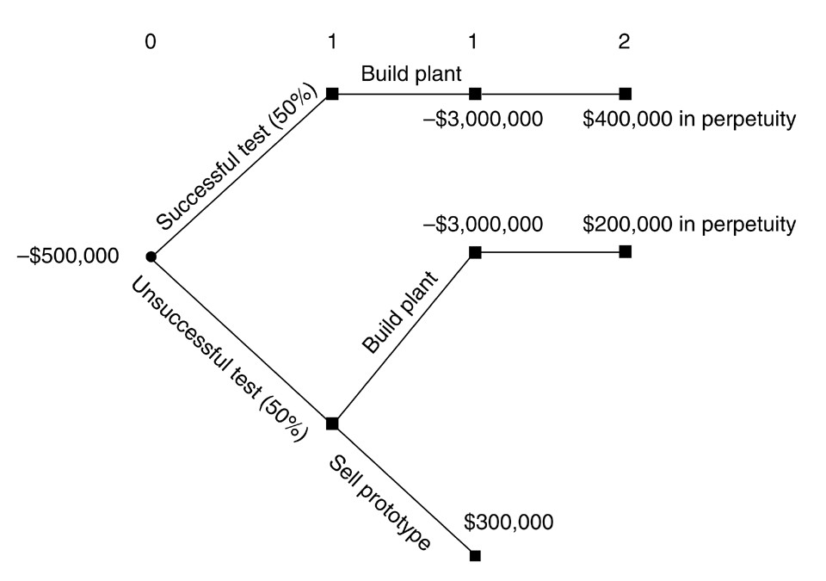
Diff: 2
Section: 22.3 The Option to Delay an Investment Opportunity
Skill: Analytical
9) Assuming that Kinston does not have the ability to sell the prototype in year one for $300,000, draw a decision tree detailing the Kinston Industries Mountain Bike Project.
Answer:
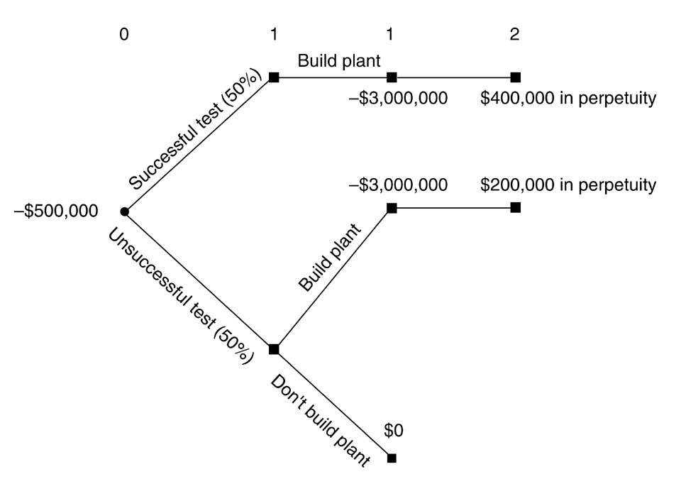
Diff: 2
Section: 22.3 The Option to Delay an Investment Opportunity
Skill: Analytical

10) Assume that Kinston has the ability to ignore the pilot production and test marketing and to go ahead and build their manufacturing plant immediately. Further assume that the probability of high or low demand is still 50%. Draw a decision tree that details Kinston Industries Mountain Bike project if Kinston goes ahead and builds the plant immediately.
Answer:
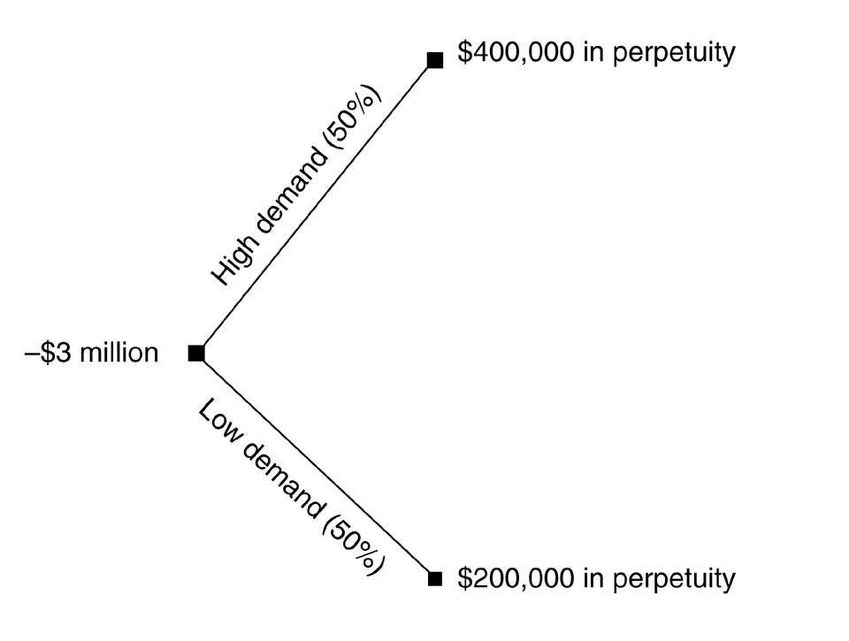
Diff: 2
Section: 22.3 The Option to Delay an Investment Opportunity
Skill: Analytical
11) Describe the two factors that affect the value of an investment timing option?
Answer: Volatility: By delaying an investment, we can base our decision on additional information. The option to wait is most valuable when there is a great deal of uncertainty regarding what the value of the investment will be in the future. If there is little uncertainty, the benefit of waiting is diminished.

Dividends: Recall that absent dividends, it is not optimal to exercise a call option early. In the real option context, the dividends correspond to any value from the investment that we give up by waiting. It is always better to wait unless there is a cost to doing so. The greater the cost, the less attractive the option to delay becomes.
Diff: 2
Section: 22.3 The Option to Delay an Investment Opportunity
Skill: Conceptual

12) Luther Industries is considering launching a new toy just in time for the Christmas season. They estimate that if Luther launches the new toy this year it will have an NPV of $25 million. Luther has the option to wait one year until the next Christmas season to launch the toy, however, the demand next year will depend upon what new toys Luther's competitors introduce and therefore greater uncertainty about next years demand. Launching the new today will involve a total capital expenditure of $100 million. If the risk-free rate is 5%, N(d1) is .62 and N(d2) is .65, then what is the value of the option to wait until next year to launch the new toy?
Answer: C = S × N(d1) - PV(K) × N(d2)
C = ($100 + $25) × .62 - 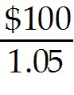 × .65 = $15.595 or $15.6 million
Diff: 2
Section: 22.3 The Option to Delay an Investment Opportunity
Skill: Analytical

22.4 Growth and Abandonment Options

1) Which of the following statements is FALSE?
A) It is tempting to use the Black-Scholes formula to value future growth options, but often there are good reasons why this formula might not price these options correctly.
B) When a firm has a real option to invest in the future it is known as a growth option.
C) Because growth options have value, they contribute to the value of any firm that has future possible investment opportunities.
D) Future growth opportunities can be thought of as a collection of real put options on potential projects.
Answer: D
Explanation: D) Future growth opportunities can be thought of as a collection of real call options on potential projects.
Diff: 2
Section: 22.4 Growth and Abandonment Options
Skill: Conceptual
2) Which of the following statements is FALSE?
A) An alternative to using the Black-Scholes formula is to compute the value of growth options using risk neutral probabilities.
B) Future growth options are not only important to firm value, but can also be important in the value of an individual project.
C) While the Black-Scholes formula values American options, most growth options cannot be exercised at any time.
D) Out-of-the-money calls are riskier than in-the-money calls, and because most growth options are likely to be out-of-the-money, the growth component of firm value is likely to be riskier than the ongoing assets of the firm.
Answer: C
Explanation: C) While the Black-Scholes formula values European options, most growth options can be exercised at any time.
Diff: 2
Section: 22.4 Growth and Abandonment Options
Skill: Conceptual

3) Which of the following statements is FALSE?
A) Abandonment options can add value to a project because a firm can drop a project if it turns out to be unsuccessful.
B) Corporate bonds often contain embedded abandonment options: The issuing firm sometimes has the option to convert the bond—that is, to repay it.
C) An abandonment option is the option to walk away.
D) An important abandonment option that most people encounter at some point in their lives is the option to abandon their mortgage.
Answer: B
Explanation: B) Corporate bonds often contain embedded abandonment options: The issuing firm sometimes has the option to call the bond—that is, to repay it.
Diff: 2
Section: 22.4 Growth and Abandonment Options
Skill: Conceptual

4) Which of the following statements is FALSE?
A) Often, the decision to abandon a project entails costs, which may be either positive or negative.
B) Mortgage interest rates are higher than Treasury rates because mortgages have an abandonment option that Treasuries do not have: You can prepay your mortgage at any time, while the U.S. government can repay its debt only according to the schedule outlined in the bond contract.
C) A popular option gives holders of the bond the option to convert the bond into equity. These kinds of bonds are termed callable bonds.
D) More often than not, there is an opportunity cost of abandoning a project: If you shut down the project and later decide to start it up again, you have to pay the costs of restarting the project.
Answer: C
Explanation: C) A popular option gives holders of the bond the option to convert the bond into equity. These kinds of bonds are termed convertible bonds.
Diff: 2
Section: 22.4 Growth and Abandonment Options
Skill: Conceptual
5) The idea that once a manager makes a large investment, he should not abandon the project is known as the:
A) negative NPV fallacy.
B) abandonment fallacy.
C) sunk cost fallacy.
D) dependence fallacy.
Answer: C
Diff: 1
Section: 22.4 Growth and Abandonment Options
Skill: Definition

Use the information for the question(s) below.

You own a small manufacturing plant that currently generates revenues of $2 million per year. Next year, based upon a decision on a long-term government contract, your revenues will either increase by 20% or decrease by 25%, with equal probability, and stay at that level as long as you operate the plant. Other costs run $1.6 million dollars per year. You can sell the plant at any time to a large conglomerate for $5 million and your cost of capital is 10%.

6) If you are awarded the government contract and your sales increase by 20%, then the value of your plant will be closest to:
A) $5 million
B) $8 million
C) $0
D) $4 million
Answer: B
Explanation: B) V = 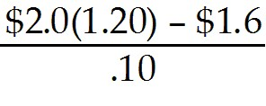 = $8 million
Diff: 2
Section: 22.4 Growth and Abandonment Options
Skill: Analytical

7) If you are not awarded the government contract and your sales decrease by 25%, then the value of your plant will be closest to:
A) -$1 million
B) $5 million
C) $8 million
D) $0
Answer: B
Explanation: B) V = 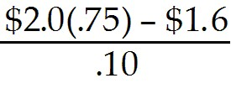 = -$1 million, however we could abandon at any time and receive $0, or better yet, we could sell the plant for $5 million, so this becomes the appropriate value.
Diff: 2
Section: 22.4 Growth and Abandonment Options
Skill: Analytical
8) Given the embedded option to sell the plant, the value of your plant will be closest to:
A) $5.0 million
B) $4.0 million
C) $6.5 million
D) $8.0 million
Answer: C
Explanation: C) Value if revenues increase
V = = $8 million

Value if revenue decreases
V = = -$1 million, however you could sell the plant for $5 million, so this becomes the appropriate value.

Value with embedded options
V = (.5)($8) + (.5)($5) = $6.5 million
Diff: 2
Section: 22.4 Growth and Abandonment Options
Skill: Analytical

9) Assume that you are not able to sell the plant, but you are able to shut down the plant at no cost at any time. Given the embedded option to abandon production the value of your plant will be closest to:
A) $8.0 million
B) $4.0 million
C) $5.0 million
D) $6.5 million
Answer: B
Explanation: B) Value if revenues increase
V = = $8 million

Value if revenue decreases
V = = -$1 million, however you could abandon production and receive $0, so this becomes the appropriate value.

Value with embedded options
V = (.5)($8) + (.5)($0) = $4.0 million
Diff: 2
Section: 22.4 Growth and Abandonment Options
Skill: Analytical
10) Assume that you are not able to sell the plant, but you are able to shut down the plant at no cost at any time. The value of the option to abandon production will be closest to:
A) $1.0 million
B) $0.5 million
C) -$1.0 million
D) $3.0 million
Answer: B
Explanation: B) Value if revenues increase
V = = $8 million
Value if revenue decreases
V = = -$1 million,
however if you could abandon production you would receive $0

Value with embedded option
V = (.5)($8) + (.5)($0) = $4.0 million

Value without embedded option:
V = (.5)($8) + (.5)(-$1) = $3.5 million

So, the option to abandon is worth $4 million - $3.5 million = $0.5 million
Diff: 2
Section: 22.4 Growth and Abandonment Options
Skill: Analytical
11) Assume that it will cost you $1 million to shut down the plant, but you are able to sell the plant for $5 million at any time. The value of the option to sell the plant will be closest to:
A) $3.0 million
B) $6.0 million
C) $5.0 million
D) $0.5 million
Answer: A
Explanation: A) Value if revenues increase
V = = $8 million
Value if revenue decreases
V = = -$1 million,
however if you could sell the plant you would receive $5 million

Value with embedded option
V = (.5)($8) + (.5)($5) = $6.5 million

Value without embedded option
V = (.5)($8) + (.5)(-$1) = $3.5 million

So, the option to sell the plant is worth $6.5 million - $3.5 million = $3.0 million
Diff: 3
Section: 22.4 Growth and Abandonment Options
Skill: Analytical

12) Assuming you are able to see the plant, draw a decision tree detailing this problem.
Answer:
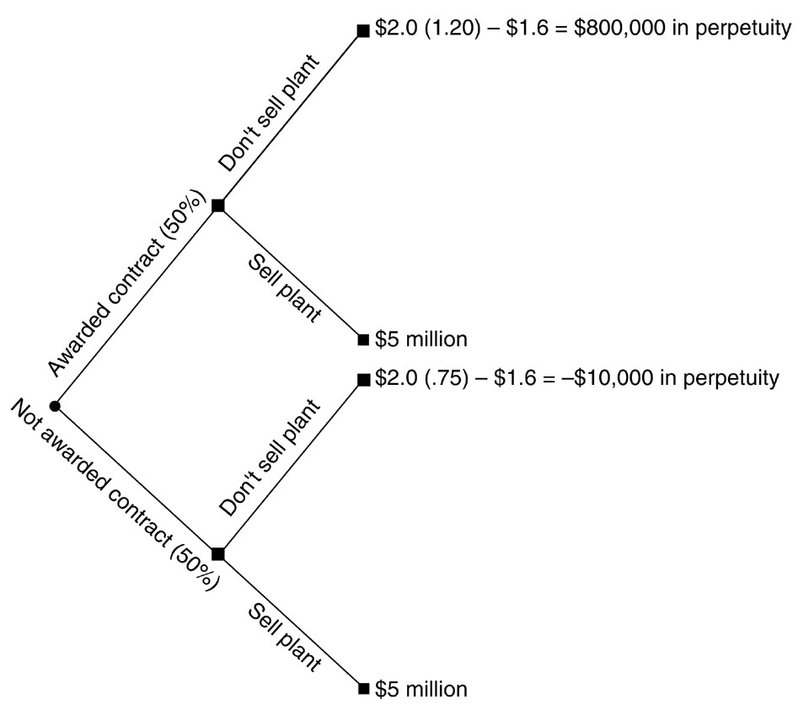
Diff: 2
Section: 22.4 Growth and Abandonment Options
Skill: Analytical
13) Assume that you are not able to sell the plant, but you are able to shut down the plant at no cost at any time. Draw a decision tree detailing this problem.
Answer:
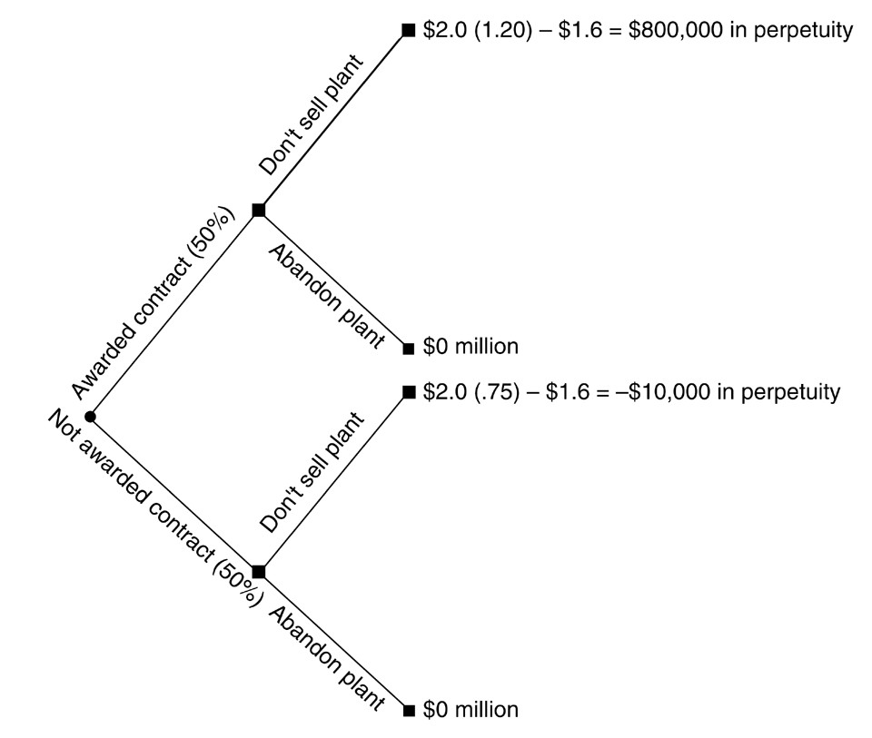
Diff: 2
Section: 22.4 Growth and Abandonment Options
Skill: Analytical

22.5 Applications to Multiple Projects

1) Which of the following statements is FALSE?
A) Traditionally, managers have used the equivalent annual benefit method to choose between projects of different lives.
B) The equivalent annual benefit method ignores the value of any real options because it assumes that the projects will always be replaced at their original terms.
C) If the future costs (or benefits) are certain with mutually exclusive projects, then we must use a real options approach to determine the correct decision.
D) The equivalent annual benefit method accounts for the difference in project lengths by calculating the constant payment over the life of the project that is equivalent to receiving the NPV today and then selecting the project with the higher equivalent annual benefit.
Answer: C
Explanation: C) If the future costs (or benefits) are certain with mutually exclusive projects, then we can ignore the real options approach when determining the correct decision.
Diff: 2
Section: 22.5 Applications to Multiple Projects
Skill: Conceptual
2) The constant annuity payment over the life of a project that is equivalent to receiving the NPV today is the:
A) annualized annuity.
B) independent annual benefit.
C) equivalent annual profitability.
D) equivalent annual benefit.
Answer: D
Diff: 1
Section: 22.5 Applications to Multiple Projects
Skill: Definition

3) Assume the NPV of a project is $1.5 million. The project is expected to last five years. What is the equivalent annual benefit if the discount rate is 8%?
A) $375,685
B) $300,000
C) $347,856
D) $324,000
Answer: A
Diff: 1
Section: 22.5 Applications to Multiple Projects
Skill: Analytical

4) Rylan Inc is considering a project that has an initial cost of $2 million. It is expected to generate cash flows for the firm of $500,000 per year for 6 years. Assuming a discount rate of 7%, what is the equivalent annual benefit?
A) $75,148
B) $80,408
C) $85,889
D) $91,901
Answer: B
Diff: 2
Section: 22.5 Applications to Multiple Projects
Skill: Analytical

5) When the value of one project depends on the outcome of one or more other projects, this is known as:
A) mutually independent investments.
B) equivalent annual investments.
C) staged dependent investments.
D) mutually dependent investments.
Answer: D
Diff: 1
Section: 22.5 Applications to Multiple Projects
Skill: Definition
6) Mutually dependent investments occur when:
A) the value of one project depends upon the outcome of one or other projects.
B) the value of one project is independent of any other projects.
C) a firm depends on another firm to provide materials for a project.
D) consumers and producers depend on each other's investments.
Answer: A
Diff: 1
Section: 22.5 Applications to Multiple Projects
Skill: Definition

Use the table for the question(s) below.

Consider the following mutually exclusive projects:

Project | Year 0  C/F | Year 1  C/F | Year 2  C/F | Year 3  C/F | Year 4  C/F | Year 5  C/F | Year 6  C/F | Year 7  C/F | Discount  Rate
A | -79 | 20 | 25 | 30 | 35 | 40 | N/A | N/A | 15%
B | -80 | 25 | 25 | 25 | 25 | 25 | 25 | 25 | 15%

7) The NPV of project A is closest to:
A) $21.70
B) $24.00
C) $18.10
D) $16.90
Answer: D
Explanation: D) C/F0 = -79
C/F1 = 20
C/F2 = 25
C/F3 = 30
C/F4 = 35
C/F5 = 40
I = 15
Compute NPV = $16.92
Diff: 2
Section: 22.5 Applications to Multiple Projects
Skill: Analytical

8) The NPV of project B is closest to:
A) $18.10
B) $21.70
C) $24.00
D) $16.90
Answer: C
Explanation: C) NPV = -80 + 25 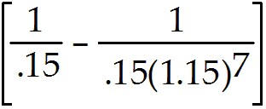 = $24.01
Diff: 2
Section: 22.5 Applications to Multiple Projects
Skill: Analytical
9) The equivalent annual benefit of project A is closest to:
A) $21.70
B) $5.05
C) $24.00
D) $3.40
Answer: B
Explanation: B) C/F0 = -79
C/F1 = 20
C/F2 = 25
C/F3 = 30
C/F4 = 35
C/F5 = 40
I = 15
Compute NPV = $16.92

PV = -16.92
FV = 0
N = 5
I = 15
Compute PMT = $5.047499
Diff: 2
Section: 22.5 Applications to Multiple Projects
Skill: Analytical

10) The equivalent annual benefit of project B is closest to:
A) $5.05
B) $5.75
C) 3.45
D) $3.40
Answer: B
Explanation: B) NPV = -80 + 25 = $24.01
PV = -24.01
FV = 0
N = 7
I = 15
Compute PMT = $5.77
Diff: 2
Section: 22.5 Applications to Multiple Projects
Skill: Analytical
11) Using the equivalent annual benefit method, which project would you select and why?
Answer: Project A
C/F0 = -79
C/F1 = 20
C/F2 = 25
C/F3 = 30
C/F4 = 35
C/F5 = 40
I = 15
Compute NPV = $16.92

PV = -16.92
FV = 0
N = 5
I = 15
Compute PMT = $5.047499

Project B
NPV = -80 + 25 = $24.01
PV = -24.01
FV = 0
N = 7
I = 15
Compute PMT = $5.77

Since the equivalent annual benefit of B > A you should take B.
Diff: 2
Section: 22.5 Applications to Multiple Projects
Skill: Analytical
22.6 Rules of Thumb

Use the following information to answer the question(s) below.

Rearden Metal can invest in a risk-free technology that requires an up-front investment of $1 million. Rearden's managers are hesitant to invest because of uncertainty over future interest rates. Suppose that all interest rates will be either 8% or 4% in one year and remain there forever. The risk-neutral probability that interest rates will drop to 4% is 40%. The one-year risk-free interest rate is 5% and today's rate on a risk-free perpetual bond is 6%. The rate on an equivalent perpetual bond that is repayable at any time (the callable annuity rate) is 7.65%.

1) Assuming that this project will provide Rearden with perpetual annual cash flows of $55,000, the NPV of investing in the project today is closest to:
A) -281,000
B) -150,000
C) -83,000
D) +83,000
E) +281,000
Answer: C
Explanation: C) NPV = 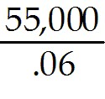 - 1,000,000 = -83,333
Diff: 3
Section: 22.6 Rules of Thumb
Skill: Analytical

2) Assuming that this project will provide Rearden with perpetual annual cash flows of $55,000, the NPV of investing in the project next year is closest to:
A) -281,000
B) -83,000
C) +46,000
D) +83,000
E) +143,000
Answer: E
Explanation: E) NPVrates at 4% = 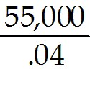 - 1,000,000 = 375,000
NPVrates at 8% = 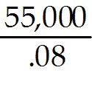 - 1,000,000 = -312,500 Therefore, won't invest if rates are 8%
NPVtoday = 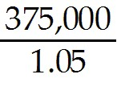 + (.6)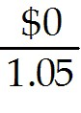 = $142,857
Diff: 3
Section: 22.6 Rules of Thumb
Skill: Analytical
3) Assuming that this project will provide Rearden with perpetual annual cash flows of $55,000, the NPV of investing in the project today using the hurdle rate is closest to:
A) -281,000
B) -150,000
C) -83,000
D) +83,000
E) +281,000
Answer: A
Explanation: A) NPV = 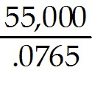 - 1,000,000 = -281,046
Diff: 3
Section: 22.6 Rules of Thumb
Skill: Analytical

4) Assuming that this project will provide Rearden with perpetual annual cash flows of $45,000, Rearden should:
A) invest today since the NPV is positive.
B) invest today since the NPV is negative.
C) invest today since the NPV using the hurdle rate is negative.
D) delay investing since the NPV using the hurdle rate is negative.
E) delay investing since the NPV using the hurdle rate is positive.
Answer: D
Explanation: D) NPV = - 1,000,000 = -281,046 (using hurdle rate)
Since this is negative Rearden should delay investment.
Diff: 2
Section: 22.6 Rules of Thumb
Skill: Analytical

5) Assuming that this project will provide Rearden with perpetual annual cash flows of $65,000, the NPV of investing in the project today is closest to:
A) -281,000
B) -83,000
C) +46,000
D) +83,000
E) +143,000
Answer: D
Explanation: D) NPV = 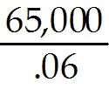 - 1,000,000 = 83,333
Diff: 3
Section: 22.6 Rules of Thumb
Skill: Analytical
6) Assuming that this project will provide Rearden with perpetual annual cash flows of $65,000, the NPV of investing in the project next year is closest to:
A) -281,000
B) +46,000
C) +83,000
D) +143,000
E) +238,000
Answer: E
Explanation: E) NPVrates at 4% = 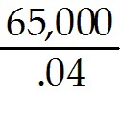 - 1,000,000 = 625,000
NPVrates at 8% = 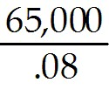 - 1,000,000 = -187,500 Therefore, won't invest if rates are 8%.
NPVtoday = (.4) 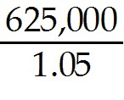 + (.6) = $238,095
Diff: 3
Section: 22.6 Rules of Thumb
Skill: Analytical

7) Assuming that this project will provide Rearden with perpetual annual cash flows of $65,000, the NPV of investing in the project today using the hurdle rate is closest to:
A) -281,000
B) -150,000
C) -83,000
D) +83,000
E) +281,000
Answer: B
Explanation: B) NPV = 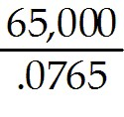 - 1,000,000 = -150,327
Diff: 3
Section: 22.6 Rules of Thumb
Skill: Analytical

8) Assuming that this project will provide Rearden with perpetual annual cash flows of $65,000, Rearden should:
A) invest today since the NPV is positive.
B) invest today since the NPV is negative.
C) invest today since the NPV using the hurdle rate is positive.
D) delay investing since the NPV using the hurdle rate is negative.
E) delay investing since the NPV using the hurdle rate is positive.
Answer: D
Explanation: D) NPV = - 1,000,000 = -150,327 (using hurdle rate)
Since this is negative Rearden should delay investment.
Diff: 2
Section: 22.6 Rules of Thumb
Skill: Analytical
9) Assuming that this project will provide Rearden with perpetual annual cash flows of $80,000, the NPV of investing in the project today using the hurdle rate is closest to:
A) -281,000
B) +46,000
C) +83,000
D) +143,000
E) +238,000
Answer: B
Explanation: B) NPV = 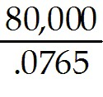 - 1,000,000 = 45,751
Diff: 3
Section: 22.6 Rules of Thumb
Skill: Analytical

10) Assuming that this project will provide Rearden with perpetual annual cash flows of $80,000, Rearden should:
A) invest today since the NPV is positive.
B) invest today since the NPV is negative.
C) invest today since the NPV using the hurdle rate is positive.
D) delay investing since the NPV using the hurdle rate is negative.
E) delay investing since the NPV using the hurdle rate is positive.
Answer: C
Explanation: C) NPV = - 1,000,000 = 45,751 (using hurdle rate)
Since this is positive, Rearden should invest immediately.
Diff: 2
Section: 22.6 Rules of Thumb
Skill: Analytical

11) Which of the following statements is FALSE?
A) The profitability index rule of thumb raises the bar on the NPV to take into account the option to wait.
B) In practice, correctly modeling the sources of uncertainty and the appropriate dynamic decisions usually requires an extensive amount of time and financial expertise.
C) Some firms use the following rule of thumb: Invest whenever the profitability index is below a specified level.
D) Instead of raising the bar on the NPV, the hurdle rate rule raises the discount rate.
Answer: C
Explanation: C) Some firms use the following rule of thumb: Invest whenever the profitability index is above a specified level.
Diff: 1
Section: 22.6 Rules of Thumb
Skill: Conceptual
12) Which of the following statements is FALSE?
A) When the investment cannot be delayed, the optimal rule is to invest whenever the profitability index is greater than zero.
B) It is often better to wait too long (use a profitability index criterion that is too high) than to invest too soon (use a profitability index criterion that is too low).
C) When the source of uncertainty that creates a motive to wait is interest rate uncertainty, the hurdle rate is relatively easy to calculate.
D) When there is an option to delay, a good rule of thumb is to invest only when the profitability index is at least 1.
Answer: B
Explanation: B) It is often better to wait too long (use a profitability index criterion that is too low) than to invest too soon (use a profitability index criterion that is too high).
Diff: 2
Section: 22.6 Rules of Thumb
Skill: Conceptual

13) Which of the following statements is FALSE?
A) The hurdle rate rule for projects with the option to delay uses a lower discount rate than the cost of capital to compute the NPV, but then applies the regular NPV rule: Invest whenever the NPV calculated using this lower discount rate is positive.
B) While using a hurdle rate rule for deciding when to invest might be a cost-effective way to make investment decisions, it is important to remember that this rule does not provide an accurate measure of value.
C) When the cash flows are constant and perpetual, and the reason to wait derives solely from interest rate uncertainty, the hurdle rate rule of thumb is always exact. However, when these conditions are not satisfied, the rule of thumb merely approximates the correct decision.
D) When a firm faces the same uncertainty for most of its investment decisions, using a single profitability index criterion for all projects can provide a useful rule of thumb to account for cash flow uncertainty.
Answer: A
Explanation: A) The hurdle rate rule for projects with the option to delay uses a higher discount rate than the cost of capital to compute the NPV, but then applies the regular NPV rule: Invest whenever the NPV calculated using this lower discount rate is positive.
Diff: 2
Section: 22.6 Rules of Thumb
Skill: Conceptual

14) The rate on a risk-free annuity that can be called at any time is known as the:
A) callable annuity rate.
B) callable auction rate.
C) callable hurdle rate.
D) risk-free rate.
Answer: A
Diff: 1
Section: 22.6 Rules of Thumb
Skill: Definition
15) The callable annuity rate can be calculated as:
A) 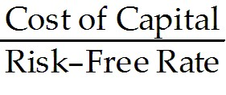 × Hurdle Rate
B) 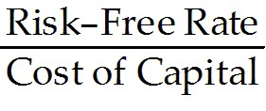 × Hurdle Rate
C) 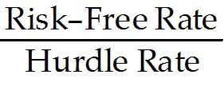 × Cost of Capital
D) 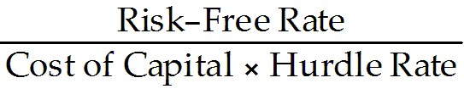
Answer: B
Diff: 2
Section: 22.6 Rules of Thumb
Skill: Definition

22.7 Key Insights from Real Options

1) The major principles to remember when considering real options include all of the following EXCEPT:
A) out-of-the-money real options have value.
B) in-the-money real options need to be exercised immediately.
C) waiting is valuable.
D) create value by exploiting real options.
Answer: B
Diff: 2
Section: 22.7 Key Insights from Real Options
Skill: Definition

2) Which of the following is an example of a way in which companies can create value by exploiting real options?
A) Abandoning good projects in favor of newer projects
B) Acting quickly to take on new projects, even if there is no cost to waiting
C) Exercising in-the-money real options immediately
D) Optimally delaying or abandoning projects
Answer: D
Diff: 2
Section: 22.7 Key Insights from Real Options
Skill: Definition

3) Do out-of-the-money real options have value?
Answer: Even if an investment opportunity currently has negative NPV, it does not imply that the opportunity is worthless. So long as there is a chance that the investment opportunity could have a positive NPV in the future, the opportunity is worth something today.
Diff: 2
Section: 22.7 Key Insights from Real Options
Skill: Definition
4) Can value be created by waiting for uncertainty to resolve?
Answer: Value can be created by waiting for uncertainty to resolve because once it is resolved you can make better decisions with better information. If there is no cost to waiting, investing early never makes sense. If there is a cost, the benefits must be weighed.
Diff: 2
Section: 22.7 Key Insights from Real Options
Skill: Definition

